install windows server 2019

set the static ip address eg (192.168.1.200)

install IIS on the server

install node js 18.0 version

download browser edge / chrome (optional)

install visual studio 2019 x64 redistribution

install MySQL community version 8.2.0

after MySQL installation completed mysql configuration windows is open

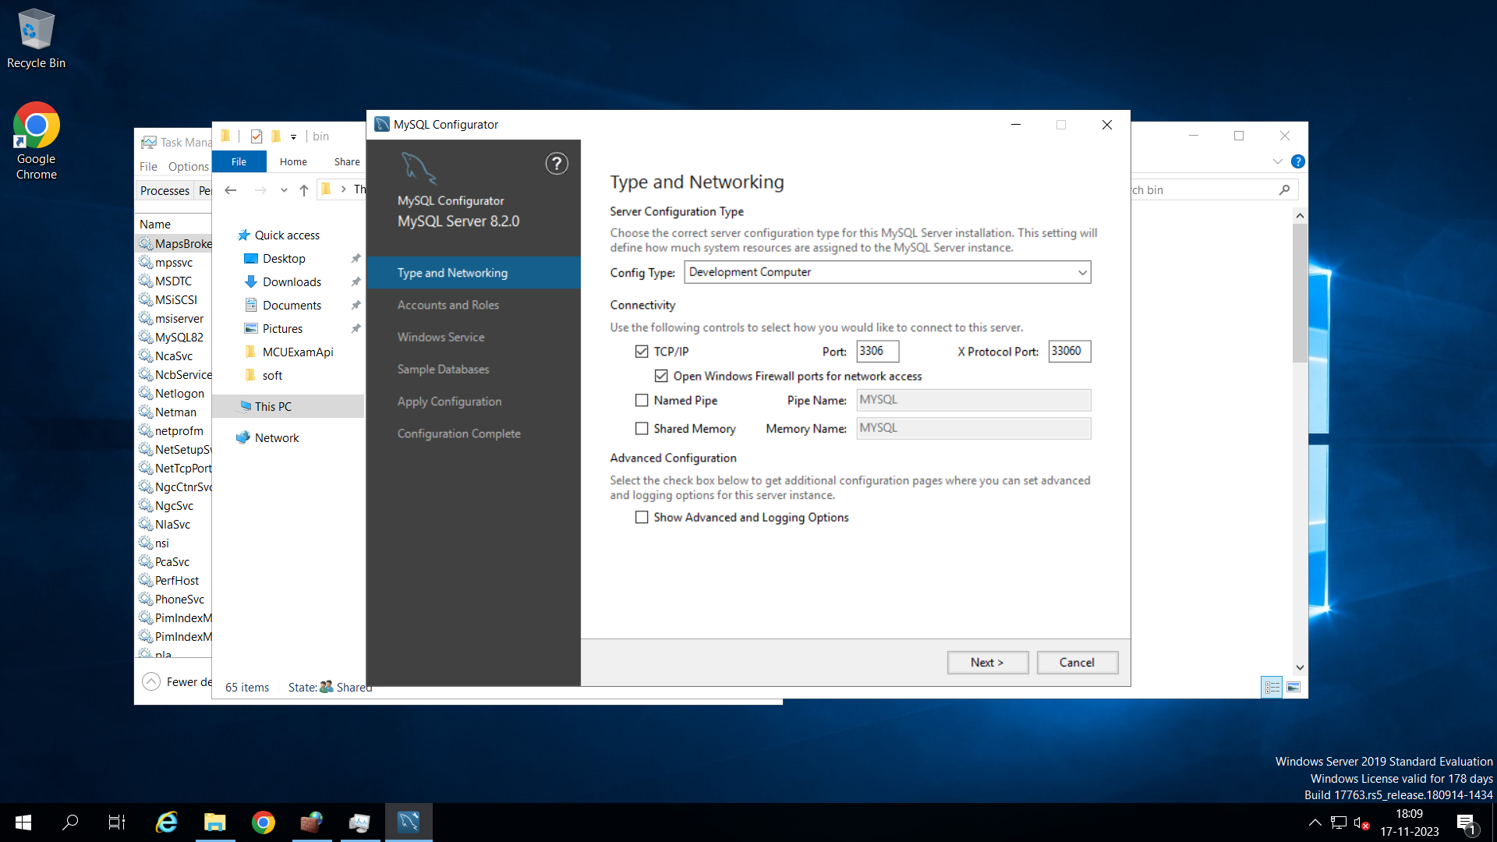

Check the option

set root password to giit (or any)

check mysql server start when windows start

install iisnode

install IIS

expend application development and tick all options

install url_rewrite

copy MCUExamApi folder into c:\inetpub folder

Copy mcu-exam-web folder to c:\inetpub

Open mcu-exam-web folder properties and select security

open command prompt and change the directory to c:\inetpub\MCUExamApi

run command npm install (install dependent node js packages)

open iis manger

go to site 🡪 write click and add website

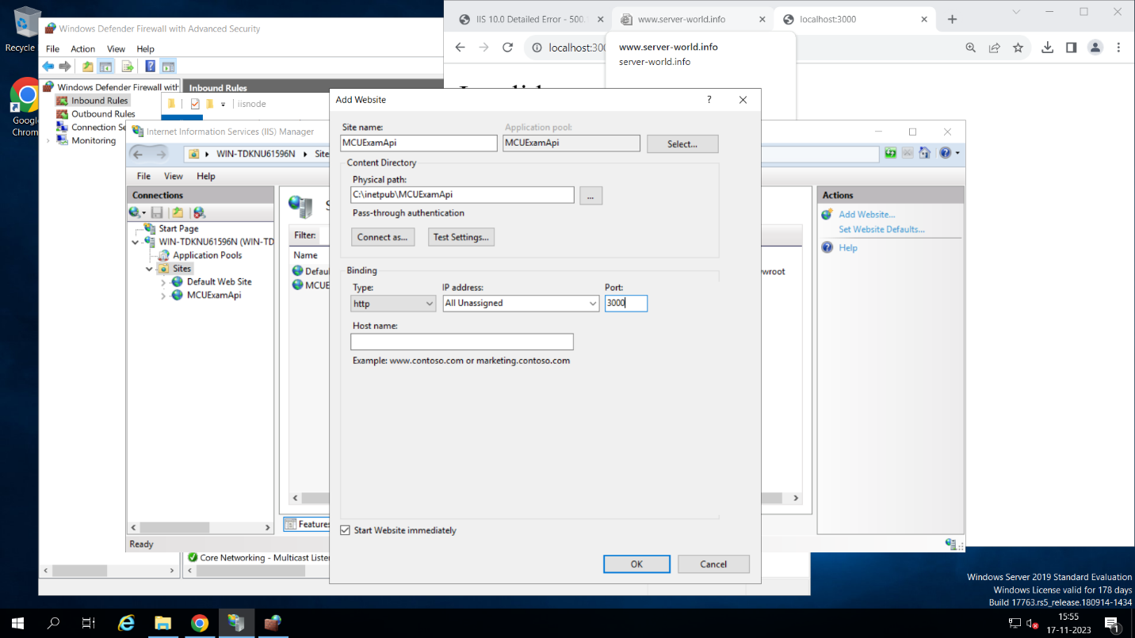

Type site name

MCUExamApi

Select application path

C:\inetpub\MCUExamApi

Type port number 3000

3

4

Press ok

1

2

Type site name

mcu-exam-web

Select application path

C:\inetpub\mcu-exam-web

Type port number 5000

3

4

Press ok

1

2

Again, go to site 🡪 write click add website

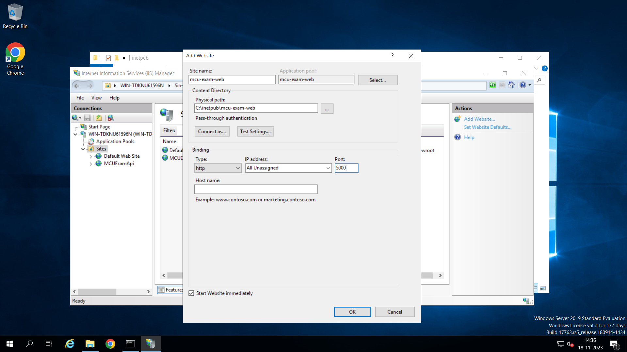

open firewall setting

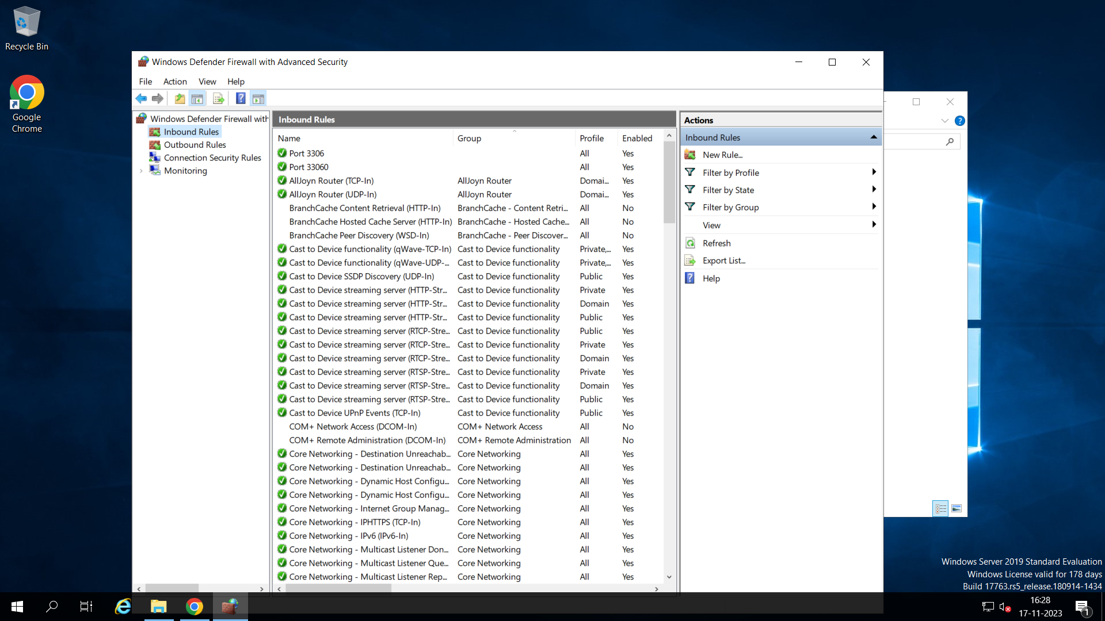

Right click on inbound rules and select new rules

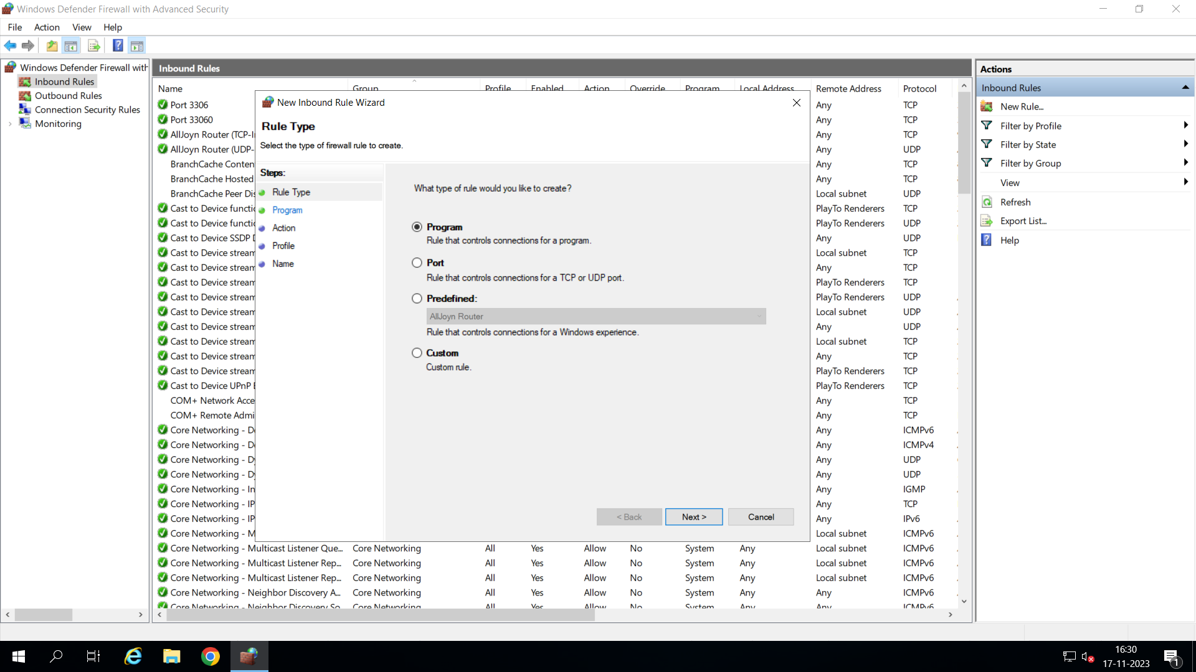

Select port and click next

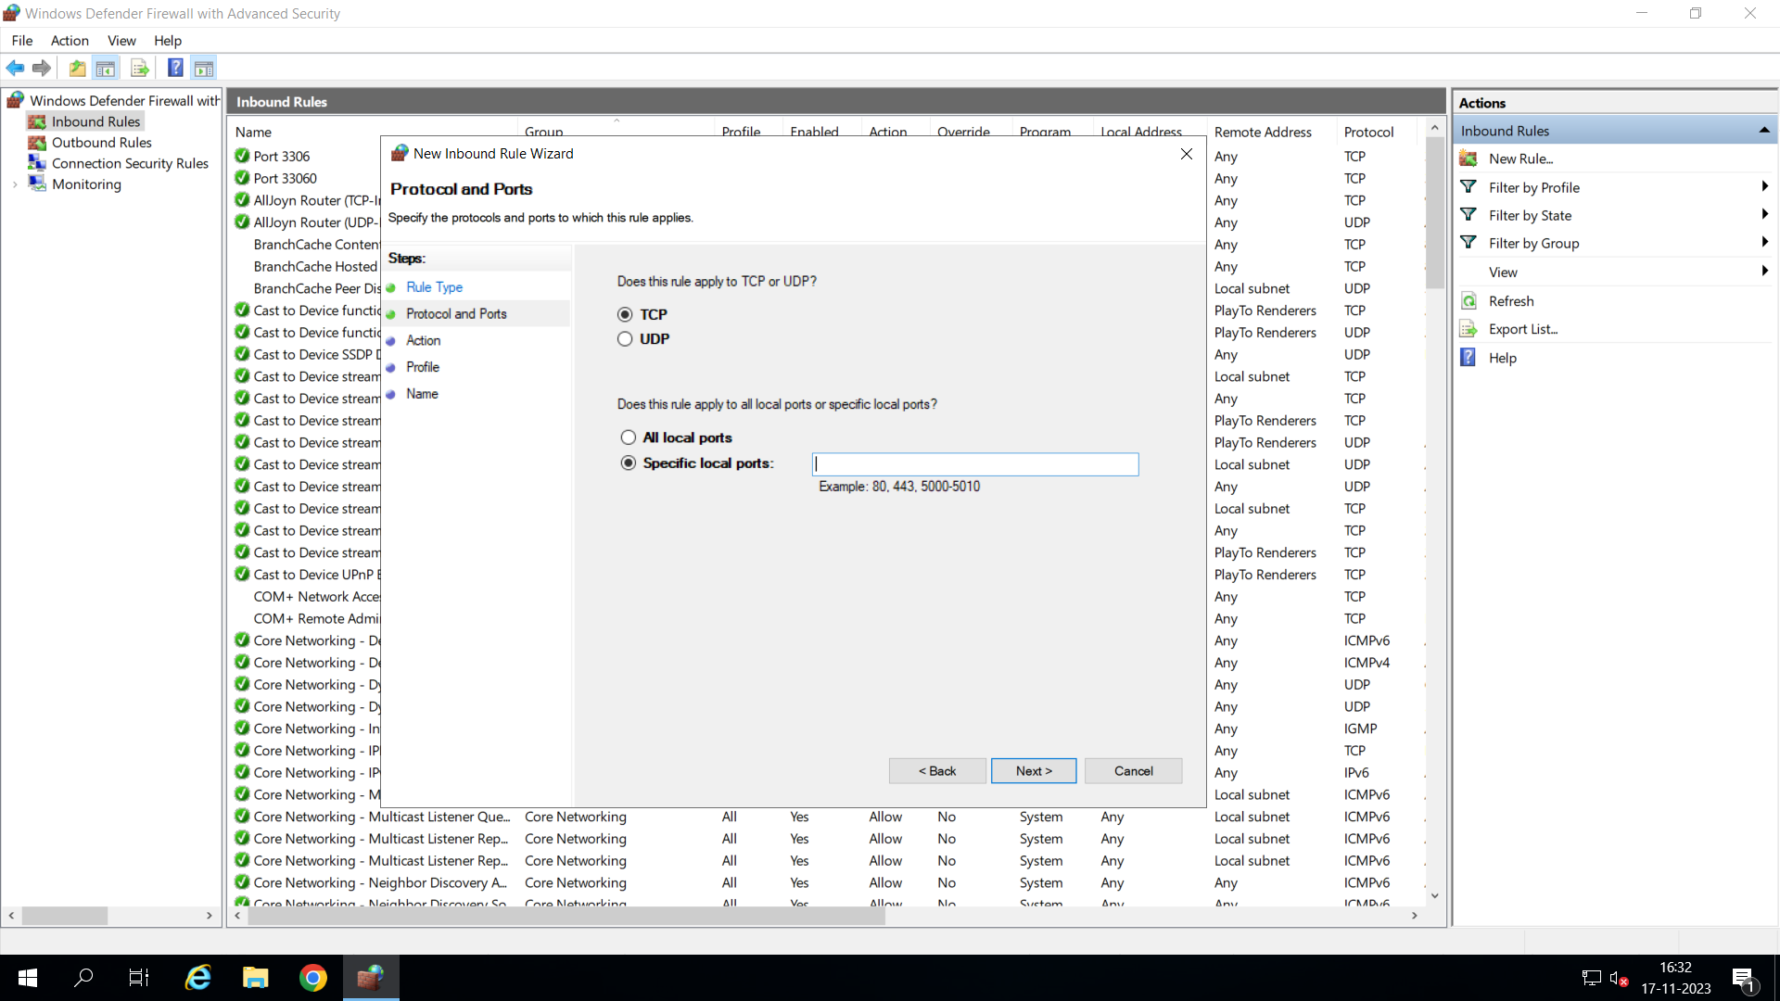

Type 3000

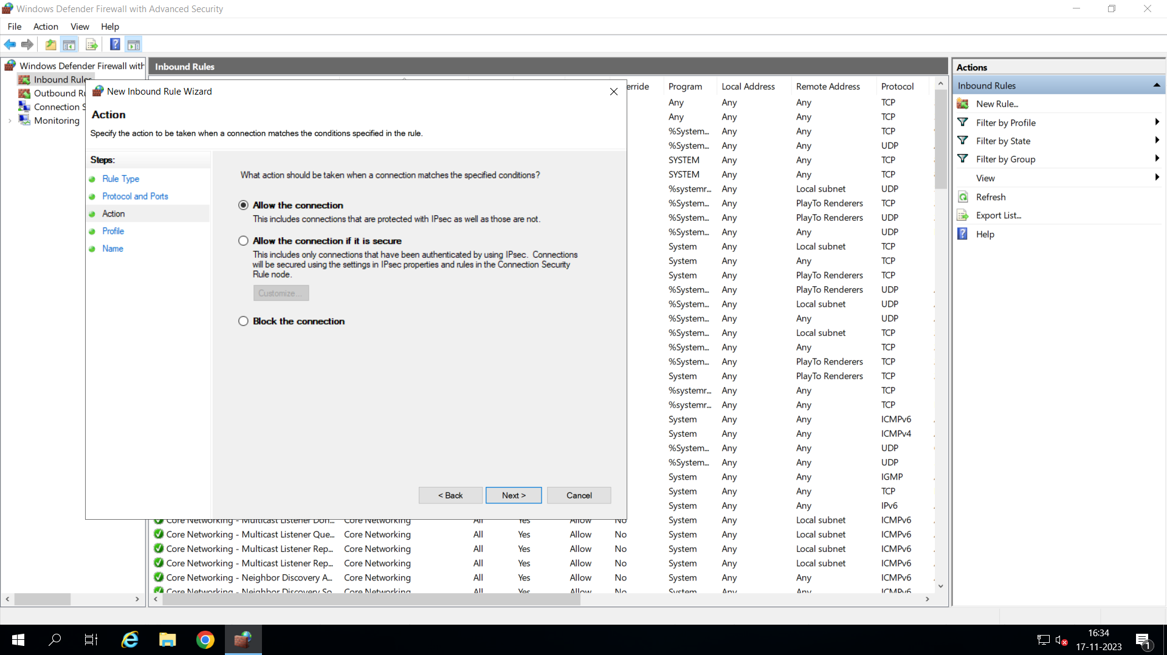

Press next

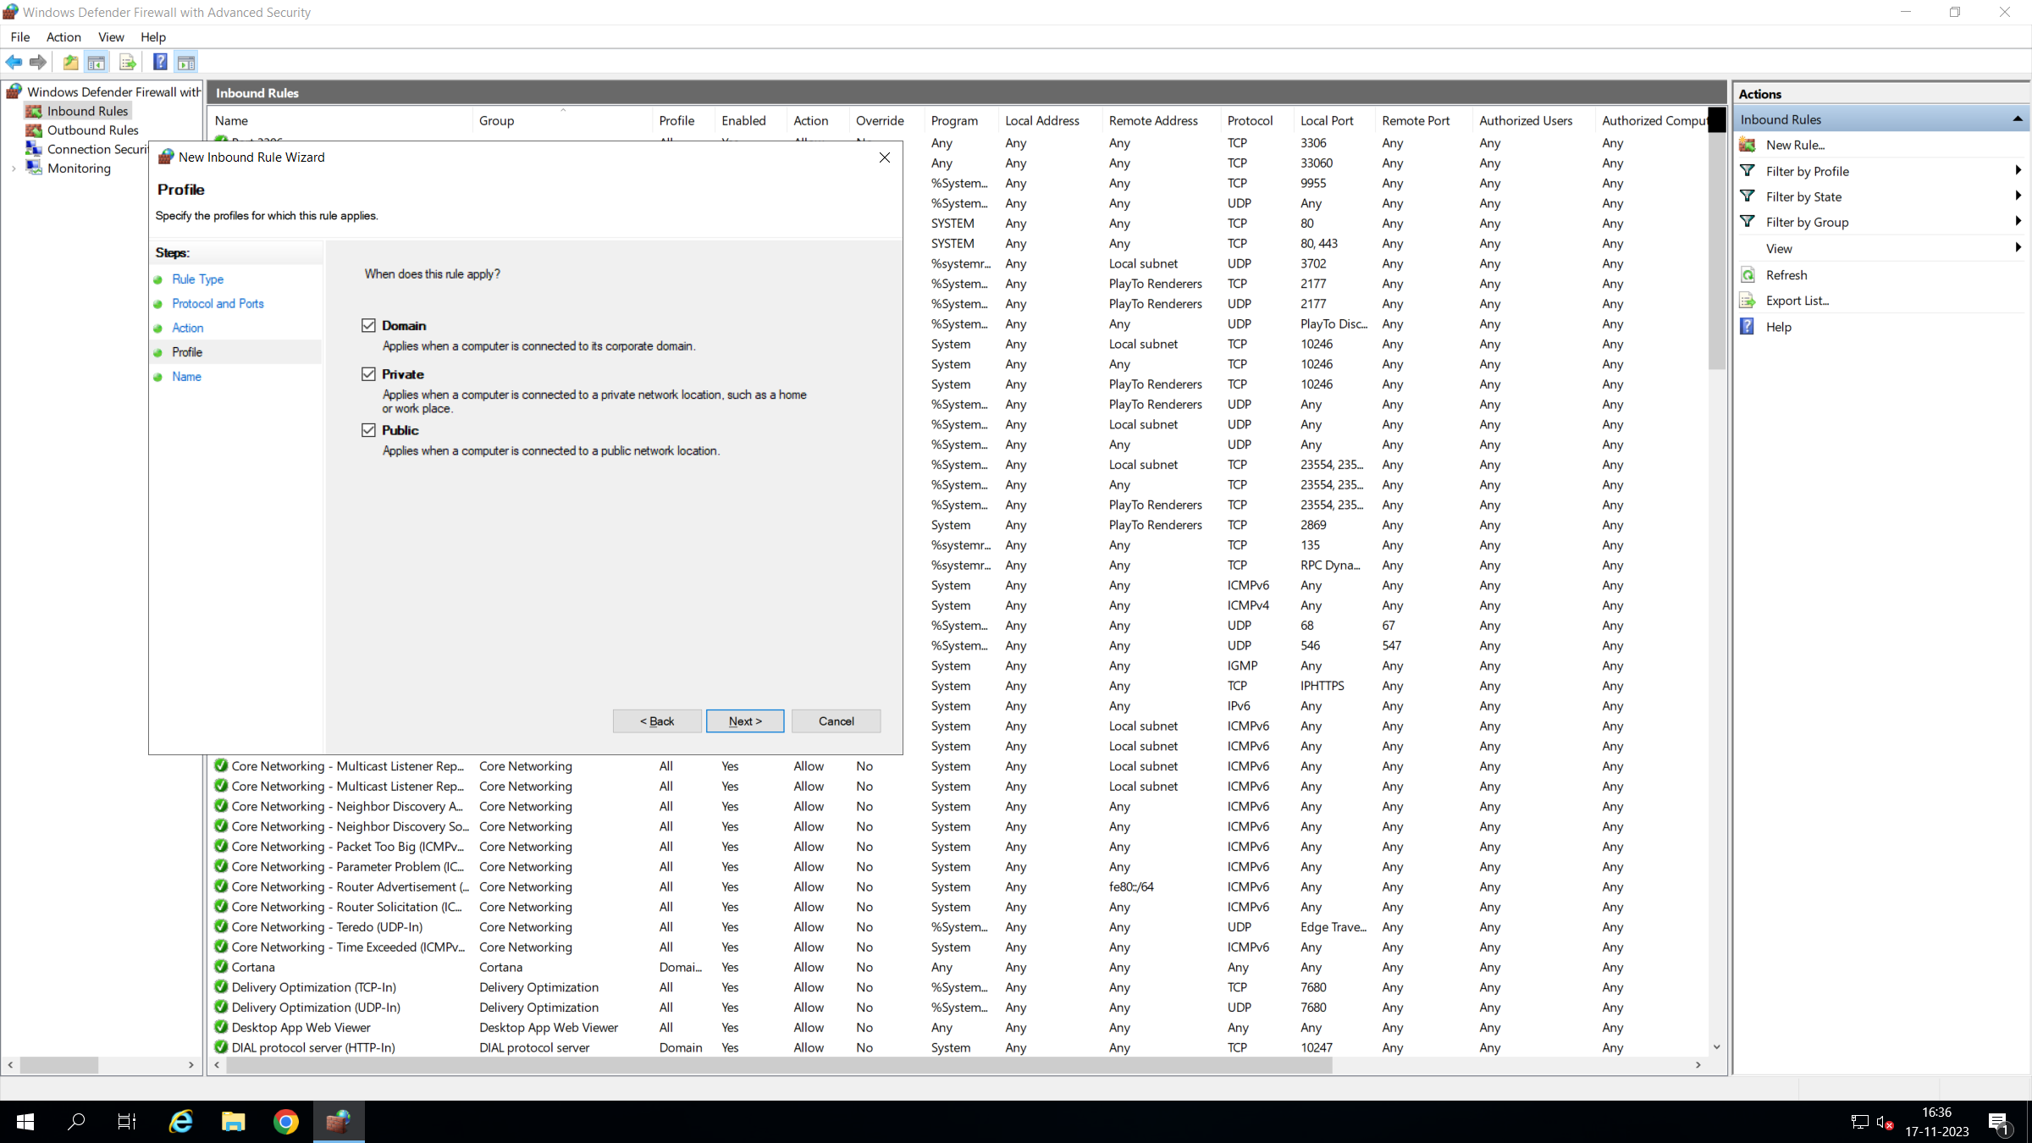

Press next

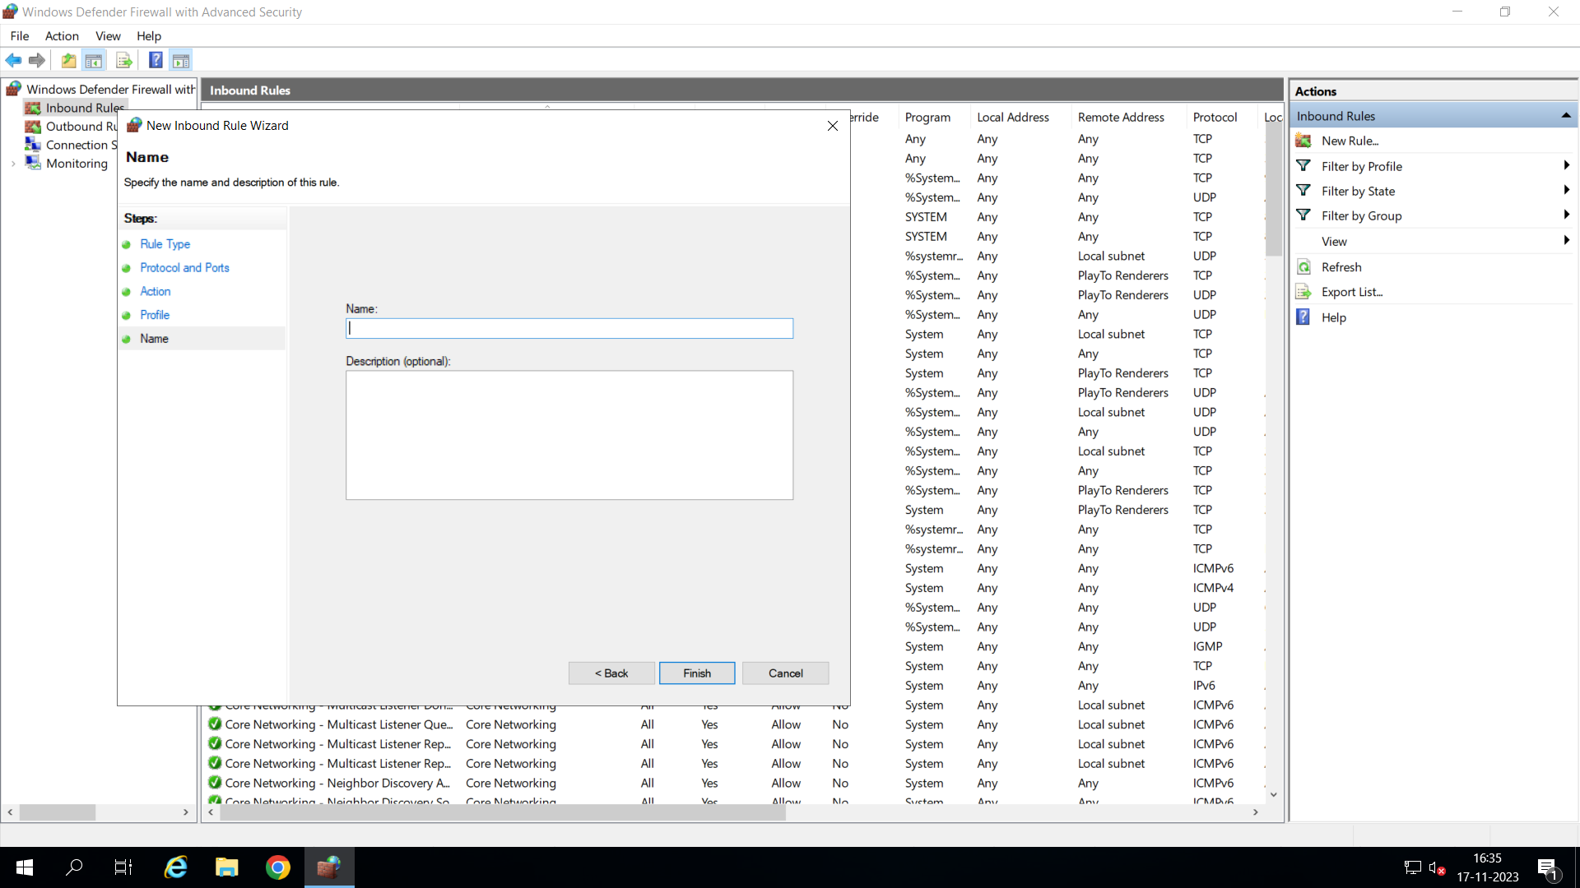

Type 3000

Press next

Follow same step again for port number 5000

Open c:\inetpub\mcu-exam-web\assets\config\config.josn file in notepad

Change "serverIp" value to <http://server-ip-address:3000>

Save and close

Open c:\inetpub\MCUExamApi\.env file on notepad and change these settings

MYSQL_USERNAME=”root”

MYSQL_PASSWORD=”giit” 🡺 MySQL password which is set when MySQL install

MYSQL_DATABASE=”mcuexam”

Set mysql installation path eg (C:\Program Files\MySQL\MySQL Server 8.2\bin)

To the system environment variable

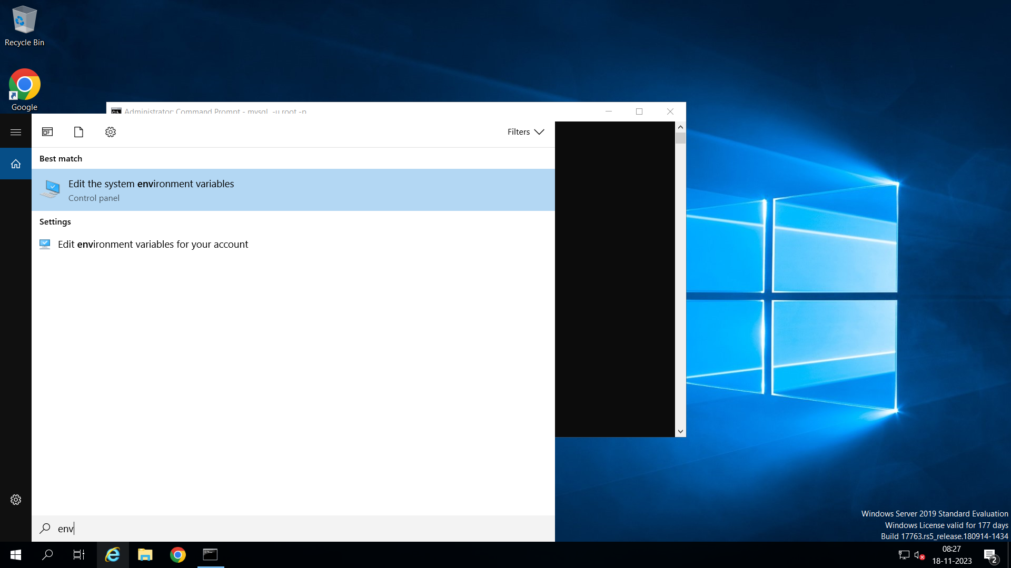

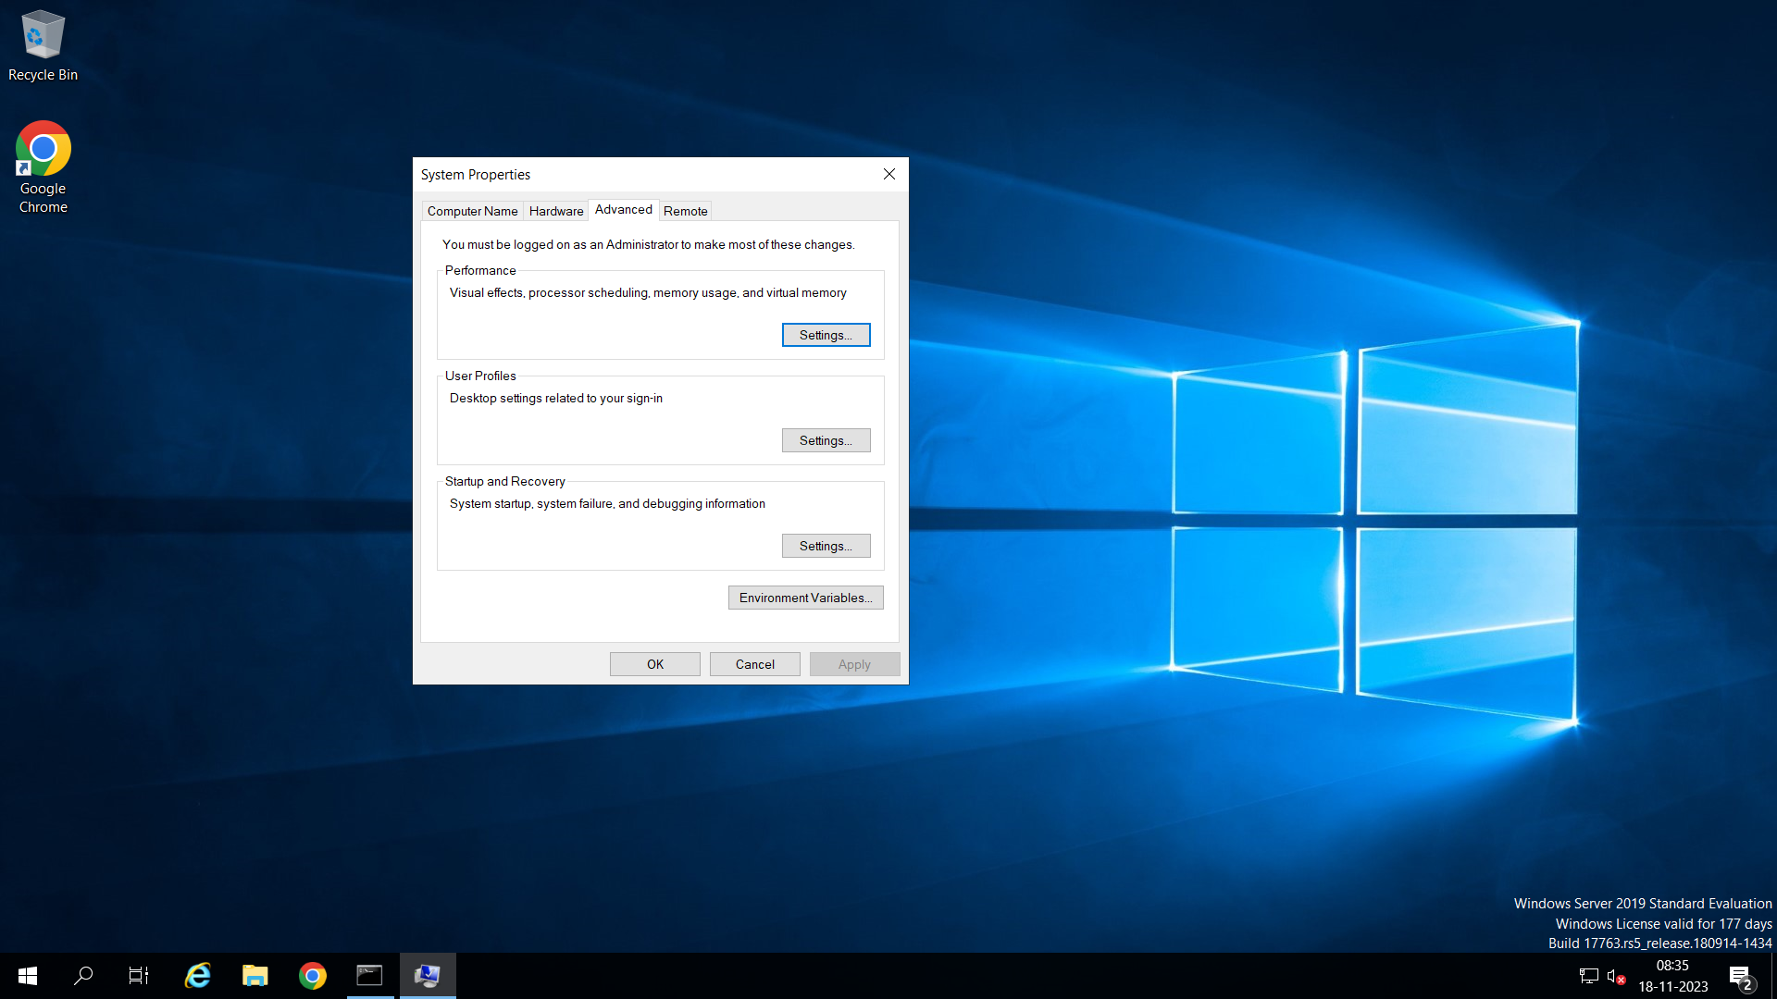

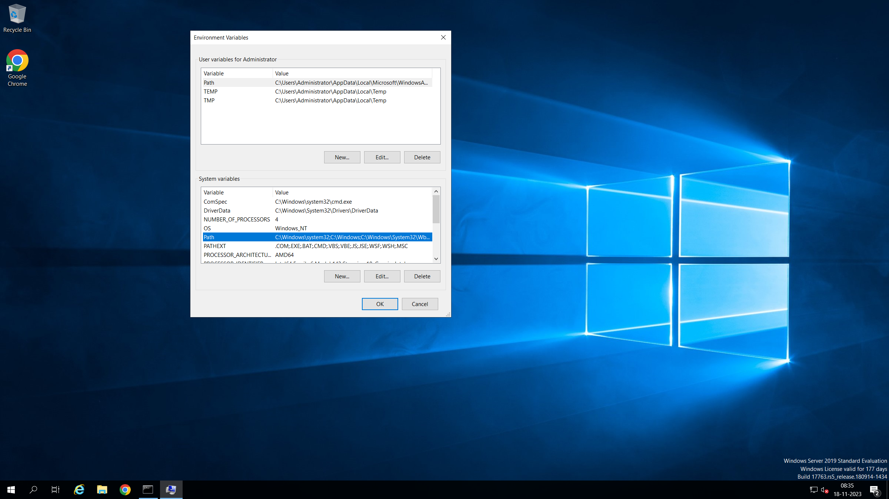

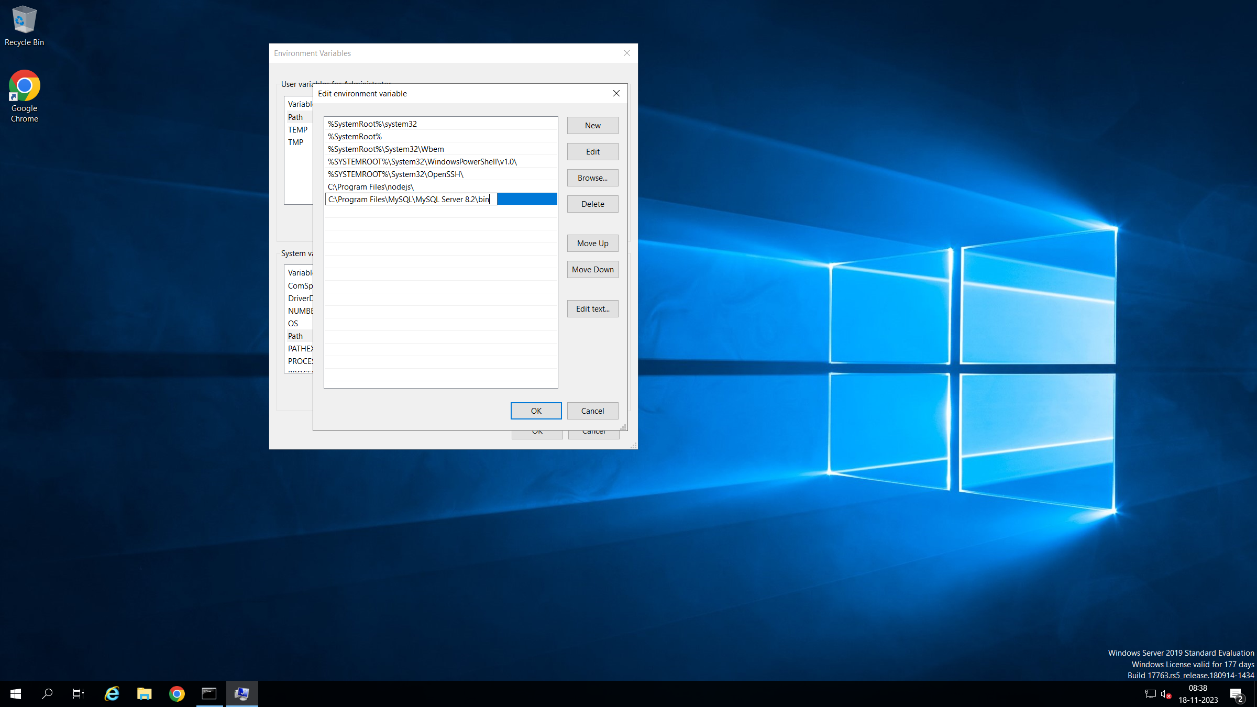

Open command prompt and change the directory to c:\inetpub\MCUExamApi\db-backup

And run command

mysql -u <mysql_user_name> -p < sql_dump_file_name

enter mysql password

